1️⃣ First class
Good afternoon, Milena.
Welcome to your first English class. This is the beginning of an exciting academic journey, and I’m truly happy to support you along the way.
Your work as a social researcher in public health is not only important, it’s essential. Helping communities better understand and respond to diseases like yellow fever has a real impact in the world. For that reason, being able to communicate your research clearly and confidently in English will open even more doors, both professionally and globally.
In today’s class, we’ll focus on two key areas: listening and speaking, since those are the skills you told me you want to strengthen the most. The activity we’ll do is a listening and comprehension task based on your own context: your current research. You’ll listen to a short text about your work and then answer questions to test your understanding.
Why are we doing this? Because listening to real, relevant English and practicing how to respond is one of the fastest ways to improve fluency, pronunciation, and confidence. These types of exercises help train your ear, expand your vocabulary, and give you tools to express your ideas more naturally, especially in professional situations like meetings or presentations.
We’ll also take time to go over the vocabulary, practice key pronunciation points, and reflect on the structure of the language so you can start using it more comfortably.
Let’s make the most of this session. I’m excited to learn together and help you speak about your research with clarity and power.

✅ Pronunciation: This is how you say the sounds of a word correctly. Good pronunciation means making each sound clearly and putting the stress on the right syllable. For example, in European, the stress is on “pe”: Yoo-ro-PEE-an.

✅ Stress: In English, some syllables in a word or words in a sentence are pronounced louder, longer, or higher in pitch. This is called stress. For example, in vaccination, the stress is on “na”: vak-si-NA-tion.

✅ Intonation: This is the rise and fall of your voice when you speak. It shows emotions, questions, or the end of a statement. If your intonation is flat (monotone), it can sound unnatural or less engaging.

✅ Confidence: This means speaking in a way that shows you are sure of yourself and your ideas. A confident voice is clear, strong, and not too fast or too slow.

✅ Clarity: This is how easy it is for others to understand you. Speaking with clarity means using simple, correct words, and not rushing your speech.

✅ Fluency: Fluency is the ability to speak smoothly without many pauses, repetitions, or hesitations. It’s when your ideas flow naturally.

✅ Word choice: This means selecting the most appropriate and natural words in English for what you want to say. For example, saying “level of trust” instead of “trustness” is better word choice.

✅ Pauses: These are short breaks you take while speaking to separate your ideas and give the listener time to process. Using pauses correctly makes your speech sound more professional and organized.

First, we’re going to listen to the audio without taking any notes. If you like, you can close your eyes, sit comfortably, and simply focus on the sound and rhythm of the speaker. When you feel ready, we’ll press play.
Then, we’ll listen to the audio a second time, but this time I’ll show you the transcript of the text. We’ll go through it together to check how it’s written, how it’s pronounced, and where the natural pauses and intonation happen.
After that, we’ll take a moment to reflect:
- How did you feel listening to the audio the first time?
- Did you notice any difference when reading and listening at the same time?
Finally, we’ll move on to the comprehension questions. This will help you practice expressing your thoughts in English, using your own words, based on the topic you know so well, your research.
Let me know when you’re ready to start.
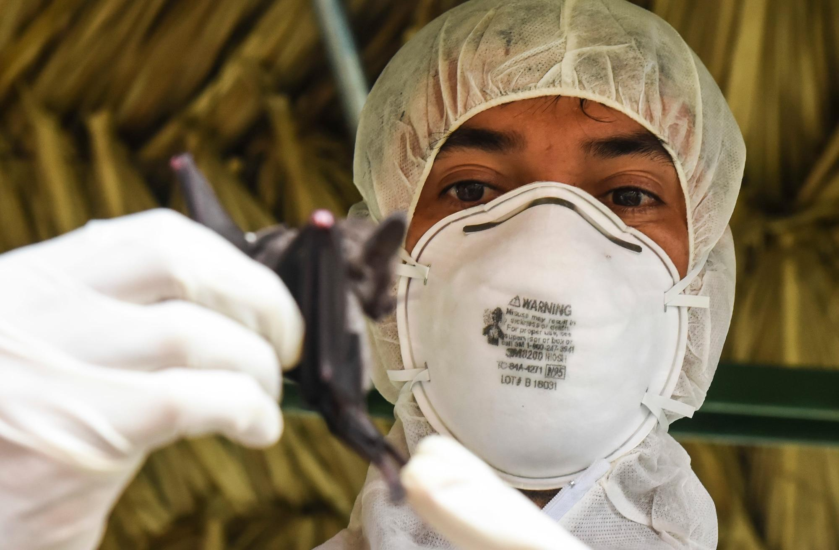

Reading & Listening Activity: Yellow Fever Research in Indigenous Communities

Title: Understanding Yellow Fever Through Social Research
My name is Milena, and I work as a social researcher at CIDEIM, a health research center in Colombia. I lead a project that focuses on the social dimensions of yellow fever, a serious viral disease transmitted by mosquitoes that affects both urban and rural populations.
Yellow fever causes symptoms such as fever, muscle pain, nausea, vomiting, and fatigue. In severe cases, it can lead to organ failure, internal bleeding, and even death. Although there is an effective vaccine, many communities still face barriers to access and information.
In this research, I work directly with indigenous communities in rural areas. Our goal is not only to understand how yellow fever spreads, but also how these communities experience the disease, access healthcare, and respond to public health messages.
Every day, I write scientific proposals and articles, collect qualitative data, and organize field visits to interview community members. We use in-depth interviews and focus groups to gather information about local beliefs, habits, and challenges related to vaccination and treatment.
What I enjoy most about my job is the direct contact with the communities. I learn from their experiences and help give visibility to their voices in public health strategies.
One of the most challenging parts of this work is presenting my findings in English. I attend meetings with international researchers once a month. These meetings are usually short, but sometimes formal. Improving my English pronunciation and fluency is important so I can explain my research clearly and professionally.
Through this project, we hope to contribute to better prevention strategies for yellow fever in vulnerable populations and support more inclusive and effective health policies.

Comprehension Questions (15 total)
Part 1: Multiple Choice (Choose the correct answer)
- What disease is Milena currently researching?
a) Malaria
b) Dengue
c) Yellow fever
d) COVID-19
- Where does Milena conduct most of her fieldwork?
a) Urban hospitals
b) Indigenous communities
c) International conferences
d) Government offices
- What is one main method used to collect data?
a) Online surveys
b) Telephone interviews
c) Focus groups and interviews
d) Blood tests
- What does Milena find most rewarding about her job?
a) Publishing in English
b) Meeting international colleagues
c) Working with communities
d) Laboratory research
- What is one difficulty Milena mentioned?
a) Traveling long distances
b) Understanding scientific theories
c) Presenting in English
d) Managing funding
Part 2: True or False
- Milena works at a hospital in Bogotá.
- Yellow fever is spread through mosquitoes.
- Milena uses qualitative methods to collect data.
- She has meetings in English once a week.
- The research helps improve health policies for rural populations.

Part 3: Open Questions (Answer in your own words)
- What is the main goal of Milena’s research?
- What are some of the symptoms of yellow fever?
- What does Milena do during her fieldwork?
- How often does she attend English meetings?
- Why is learning English important for her work?

Answer Key
Multiple Choice:
- c) Yellow fever
- b) Indigenous communities
- c) Focus groups and interviews
- c) Working with communities
- c) Presenting in English
True or False:
6. False
7. True
8. True
9. False (once a month)
10. True
Open Questions (Sample Answers):
11. To understand how yellow fever affects indigenous communities and support better public health strategies.
12. Fever, muscle pain, nausea, vomiting, fatigue, organ failure, and internal bleeding.
13. She visits communities, conducts interviews and focus groups, and collects qualitative data.
14. Once a month.
15. So she can clearly present her findings to international researchers and in global meetings.

